**Problem Statement:** -

* Add the headers in the rxnorm file provided, the headers files. And then the things should be done in the lambda and lambda should be triggered by s3 after the files drop in the s3.
* A screenshot of a computer

  Description automatically generated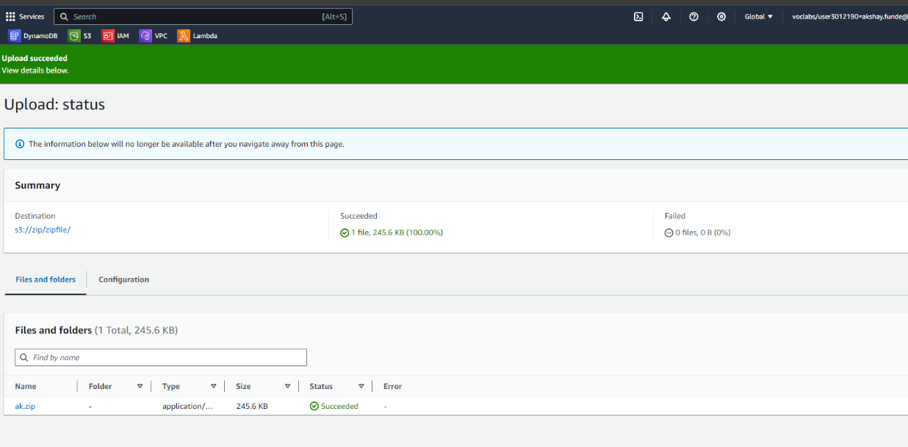A screenshot of a computer

  Description automatically generatedRxNorm file to be used for the Python + Lambda Task.



